Biography of Anjir Liton, Director General of Bangladesh Shishu Academy
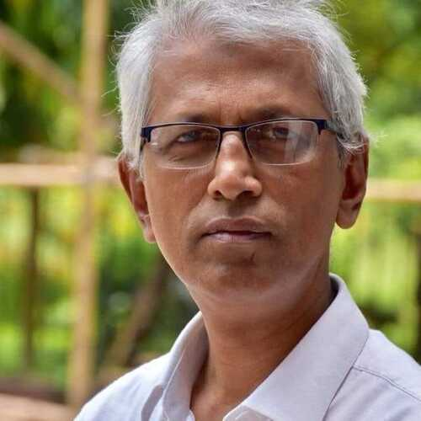
Anjir Liton

Anjir Liton (born 17 June 1965) is a Bangladeshi Poet and Children's Writer. He is the Director General of Bangladesh Children's Academy. He won Bangla Academy Literary Award for His Children's writing in 2020 for his contribution to children's literature.
Liton was born on 17 June 1965 in the Mymensingh district of Bangladesh. He spent his childhood and adolescence there. His first writing was published in Dainik Jahan. He completed his graduation in Political Science from Rajshahi University.
In 1992, Liton's first book Khara Duto Shing (খাড়া দুটো শিং) was published. Besides writing children's literature, he has planned and written various programs for television and radio. In 2016, he was appointed as the Director of Bangladesh Shishu Academy for one year on a contractual basis. He succeeded Musharraf Hossain in this position.
Now he is the Director General of Bangladesh Children's Academy.

