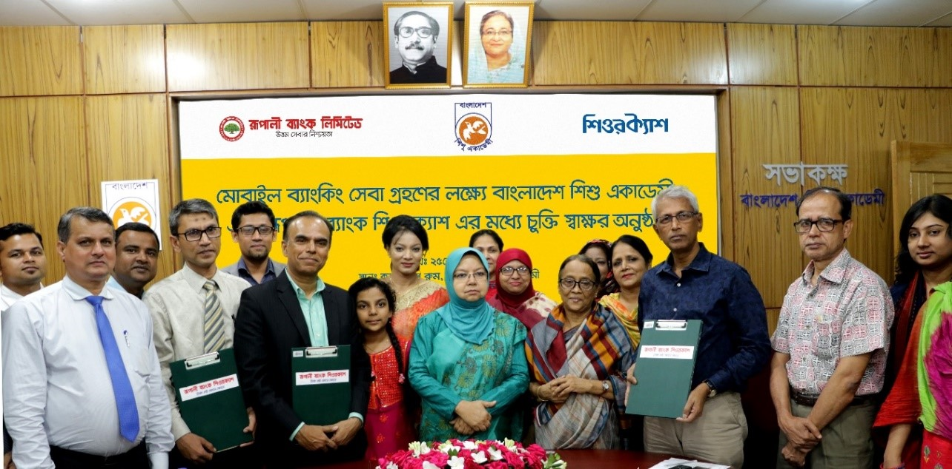

Jan 15, 2023

Bangladesh Shishu Academy has signed a tripartite agreement with Rupali Bank and SureCash to enable mobile banking services.

On June 25, 2018, Bangladesh Shishu Academy will accept the admission fee for various types of cultural training through Rupali Bank SureCash according to the agreement that was held in the Bangladesh Shishu Academy conference room.

At the signing ceremony, Secretary of Women and Children Affairs Ministry Nasima Begum, NDC; Chairman of Bangladesh Shishu Academy, Literary Selina Hossain; Director Angeer Liton; Deputy General Manager of Rupali Bank Limited Mohammad Kausar Mostafiz; Assistant General Manager Mr. Sohel Reza; Chief Executive Officer of SureCash, Dr. Shahadat Khan, Chief Business Officer Md. Abu Taleb, SVP-Business Md. Noor Al Athar and other officials were present.

Under the Ministry of Women and Children Affairs, Bangladesh Shishu Academy is currently working in 64 districts and 6 upazilas of the country including the head office. Bangladesh Shishu Academy is the only national institution to develop the cultural-emotional and creative development of children. Among the notable programs of this academy are cultural training, national child prize competition, the celebration of National Children's Day, World Children's Day and Children's Rights Week, Shishu Academy book fair, education tour, child development and pre-primary education center, child health and nutrition, daughter programs for children, creating equal opportunities for children with special needs, cultural exchange, joining international cultural festivals, Kid's Books and Regular Kid's Journals.

 From all government banks, Rupali Bank is the only Bank that is providing mobile banking services. Rupali Bank SureCash is a full-fledged mobile banking and payment service through which more than 1 crore subscribers can send money, pay bills, recharge their mobile and pay salaries to different educational institutions and deposit or withdraw money through more than 160 thousand agents.